**HANGMAN GAME**

**A Project Report**

***Submitted by:***

**Chandan Kamal (17162121003), Kasodariya Dixit (1716212010), Jessica Mangaraj (17162121009), Dhrutika Dahiya(17162121006)**

***In partial fulfillment for the Application Development Project (SEM-IV)***

***Of***

**BACHELOR OF TECHONOLOGY**

**IN**

**COMPUTER SCIENCE AND ENGINEERING (BDA)**

at



**2018-19**

**DECLARATION**

I hereby declare that the project entitled “ **Hangman** ” submitted for the B. Tech. CSE (BDA) Application Development Project is my original work.

**Signature of the Student**

**Place:**

**Date:**

**DECLARATION**

I hereby declare that the project entitled “ **Hangman** ” submitted for the B. Tech. CSE (BDA) Application Development Project is my original work.

**Signature of the Student**

**Place:**

**Date:**

**DECLARATION**

I hereby declare that the project entitled “ **Hangman** ” submitted for the B. Tech. CSE (BDA) Application Development Project is my original work.

**Signature of the Student**

**Place:**

**Date:**

**DECLARATION**

I hereby declare that the project entitled “ **Hangman** ” submitted for the B. Tech. CSE (BDA) Application Development Project is my original work.

**Signature of the Student**

**Place:**

**Date:**

**CERTIFICATE**

This is to certify that the project titled “ **Hangman** ” submitted by ***Chandan Kamal (17162121003)*** of B Tech (CSE)-SEM IV of BDA from Institute of Computer Technology, Ganpat University during the academic year 2018-19, in partial fulfillment of the requirements for the Application Development project work.

**Signature of the Guide**

**Place:**

**Date:**

**CERTIFICATE**

This is to certify that the project titled “ **Hangman** ” submitted by ***Kasodariya Dixit (17162121010)*** of B Tech (CSE)-SEM IV of BDA from Institute of Computer Technology, Ganpat University during the academic year 2018-19, in partial fulfillment of the requirements for the Application Development project work.

**Signature of the Guide**

**Place:**

**Date:**

**CERTIFICATE**

This is to certify that the project titled “ **Hangman** ” submitted by ***Jessica Mangaraj (17162121009)*** of B Tech (CSE)-SEM IV of BDA from Institute of Computer Technology, Ganpat University during the academic year 2018-19, in partial fulfillment of the requirements for the Application Development project work.

**Signature of the Guide**

**Place:**

**Date:**

**CERTIFICATE**

This is to certify that the project titled “ **Hangman** ” submitted by ***Dhrutika Dahiya (17162121006)*** of B Tech (CSE)-SEM IV of BDA from Institute of Computer Technology, Ganpat University during the academic year 2018-19, in partial fulfillment of the requirements for the Application Development project work.

**Signature of the Guide**

**Place:**

**Date:**

**Table of Contents**

|  |  |
| --- | --- |
|  |  |
|  |  |
| **1.** | **INTRODUCTION\*** |
|  | * 1. Problem Definition   2. Project Overview/Specifications* (page-1 and 3)   3. Hardware Specification   4. Software Specification |
| **2.** | **REQUIREMENT ANALYSIS** |
|  |  |
| **3.** | **SYSTEM ANALYSIS & DESIGN** |
|  | 3.1 Requirement Specification  3.2 Flowcharts / DFDs / ERDs  3.3 Design and Test Steps / Criteria  3.3 Algorithms and Pseudo Code  3.4 Testing Process |
| **4.** | **RESULTS / OUTPUTS** |
| **5.** | **CONCLUSIONS** |
| **6.** | **REFERENCES** |

1. **INTRODUCTION**

**1.1Problem Definition**

Hangman : A guessing game

**1.2 Project Overview/Specifications**

The purpose of this project is to provide user some entertainment. Basically the concept of this game is same as guessing game we use to play as kids. But, the animation and challenges make it more interesting. There will be different categories like movies, sports, countries, etc. from which one word will be selected randomly and the user have to guess it right within 10 attempts. The game will end on guessing right or when the user attempts it.

This game will provide relaxation and fun for some minutes and would help in enriching some vocabulary, and some brain skills without diverting into complete mindlessness**.**

**1.3 Hardware Specification**

* + Windows XP,7,8,10

**1.4 Software Specification**

* + XAMPP(for database )
  + Notepad++
  + GIMP

1. **REQUIREMENT ANALYSIS**

During working on our project we needed a character for animation to tell the user that if the player is not able to guess the word and what would happen to a character if he/she looses that game and a virtual keyboard for the user to select the letters to complete that word. And to make this game more interesting we needed some sounds and lives so that the user will have this game as more interacting. To store data of user and words for each level we needed database.

1. **SYSTEM ANALYSIS & DESIGN**

**3.1 Requirement Specification**

To meet the needs of our project , with the help of GIMP software designed the character for animation part. For virtual keyboard we used jquery functions and css connected with PHP to make them visible. And with these we checked if we the letter is present in the word or not and added some sounds also using jquery and css at each steps. For storing the data ,we used XAMPP server , and with MYSQL language we are able to add and delete information of the user who just logged on to play the game. And to store all the words we need a text file to store and fetch word from the text file according to the level.

**3.2 Flowcharts / DFDs / ERDs**

**🡪FLOWCHART**

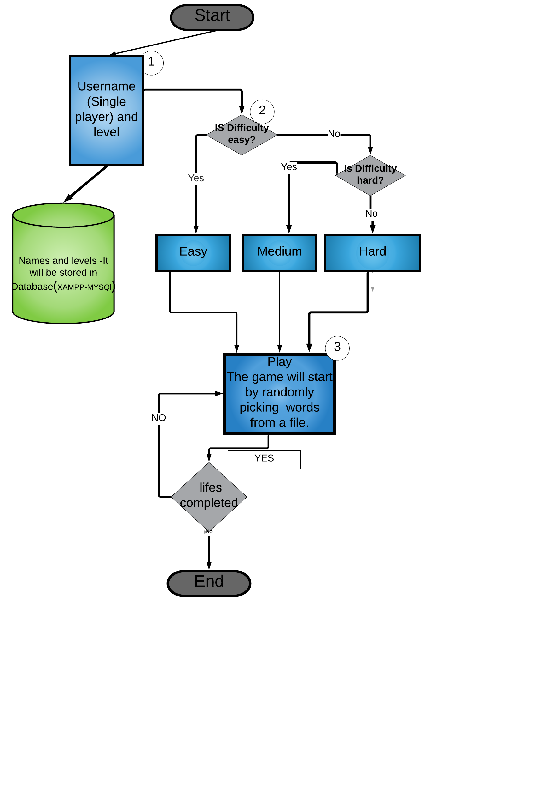

**DFD- Level 0**

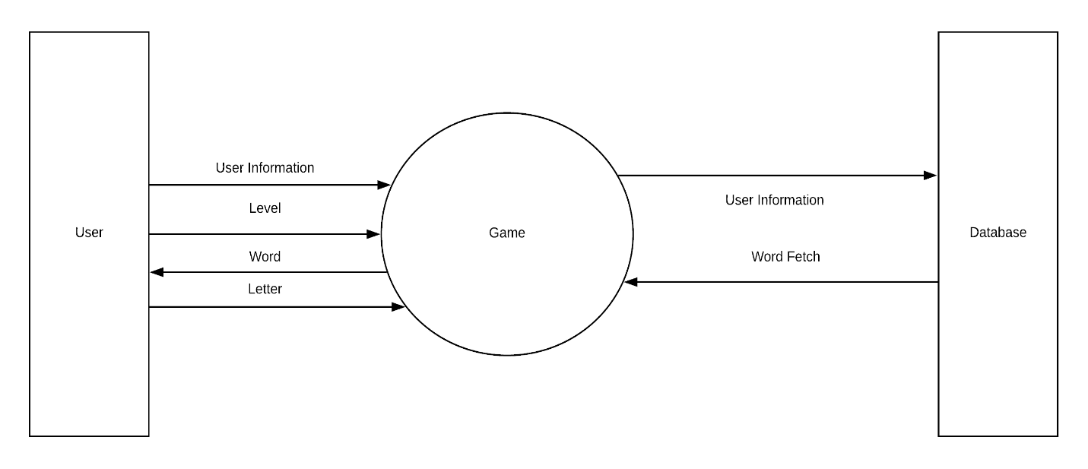

**3.3 Design and Test Steps / Criteria**

* Fetching random word : It returns a random word that is going to be used in the game from the specified text file.
* Hiding characters of the word : It hides every characters of the word that has been generated in the game.
* Checking and placing the right character: This function checks if the character entered by the user is one of the missing characters of the hidden word. If the character is found in the word, it is placed into its exact location and it goes on loop until the word has been correctly guessed within the right amount of no. of attempts.

**3.4 Algorithms and Pseudo Code**

**For Initializing:**

$db = "ad_pro";

$con=mysqli_connect("127.0.0.1","root","","ad_pro");

if (!$con)

{

die('Could not connect: ' );

mysqli_error();

}

**For registering user and level into database:**

if(isset($_POST['user_name']) || isset($_POST['level']) ){

$sql="INSERT INTO display(user_name,level) VALUES('". $_POST['user_name']. "','". $_POST['level']. "')";

if (!mysqli_query($con,$sql))

{

die('YOU ARE ALLREAD IN THIS GAME!!!!! ') ;

mysqli_error();

}

echo "";

}

**To fetch data from text file:**

$lines = file('dictionary.txt'); //name of the file containing words

$word = $lines[rand(0, count($lines) - 1)];

$word = substr($word, 0, strlen($word) -2);

**For lives left in the game and the image function changing according to the level selected:-**

switch($level)

{

case 0: // Easy

$_SESSION['lives'] = 10;

break;

case 1: // Medium

$_SESSION['lives'] = 5;

break;

case 2: // Hard

$_SESSION['lives'] = 3;

break;

}

$_SESSION['image'] = 0;

$blankWord = '';

for($i = 0; $i < strlen($word); $i++)

{

$blankWord .= (substr($word,$i,1) != ' ' ? '<span class="guessed-letter">_</span>' : ' ');

}

require 'start.php';

break;

case 2:

$response = array();

if($_SESSION['win'] == null)

{

$letter = strtolower($_POST['letter']);

if(strpos(strtolower($_SESSION['word']), $letter) === false)

{

$_SESSION['lives'] -= 1;

switch($_SESSION['level'])

{

case 0:

$_SESSION['image'] += 1;

break;

case 1:

$_SESSION['image'] += 2;

break;

case 2:

if($_SESSION['image'] == 0)

$_SESSION['image'] = 3;

elseif($_SESSION['image'] == 3)

$_SESSION['image'] = 6;

else

$_SESSION['image'] = 10;

break;

}

$response['image'] = 'images/hangman/' . $_SESSION['image'] . '.jpg';

if($_SESSION['lives'] == 0)

{

$_SESSION['win'] = false;

$response['word'] = 'The word was: <b>' . $_SESSION['word'] . '</b>';

}

}

**To find letters:-**

$_SESSION['foundLetters'] .= $letter;

$i = 0;

$wordLetters = str_split($_SESSION['word']);

$foundLetters = str_split($_SESSION['foundLetters']);

foreach($wordLetters as $letter)

{

$found = false;

foreach($foundLetters as $letter2)

{

if(strtolower($letter) == strtolower($letter2))

{

$found = true;

break;

}

}

if($found)

$i++;

}

if($i == strlen($_SESSION['word']) - substr_count($_SESSION['word'], ' '))

$_SESSION['win'] = true;

}

}

$wordLetters = str_split($_SESSION['word']);

$foundLetters = str_split($_SESSION['foundLetters']);

$guessedWord = '';

foreach($wordLetters as $letter)

{

$found = false;

foreach($foundLetters as $letter2)

{

if(strtolower($letter) == strtolower($letter2))

{

$found = true;

break;

}

}

if($found)

$guessedWord .= $letter;

elseif($letter != ' ')

$guessedWord .= '<span class="guessed-letter">_</span>';

else

$guessedWord .= ' '; }

**After selecting play again it will again go back to the the starting page:**

<a href="index.php">Play again?</a>

**3.5 Testing Process**

* We tested the game in different phases:
* Entering name and levels into database and then starting the game
* Displaying “_” same as the length of the word which is taken randomly from a text file
* Selecting a character from virtual keyboard and the selected word to be omitted out from the virtual keyboard
* The replacing the selected letter with “_” if the letter present in the word , else it would take it as a count and would decrement the count of attempts
* With each decrement of attempt it shows an image and images goes on loop to show it as a part of animation until the attempts reaches its maximum capacity
* Play again option to go to the beginning of game

1. **RESULTS / OUTPUTS**

**Login**

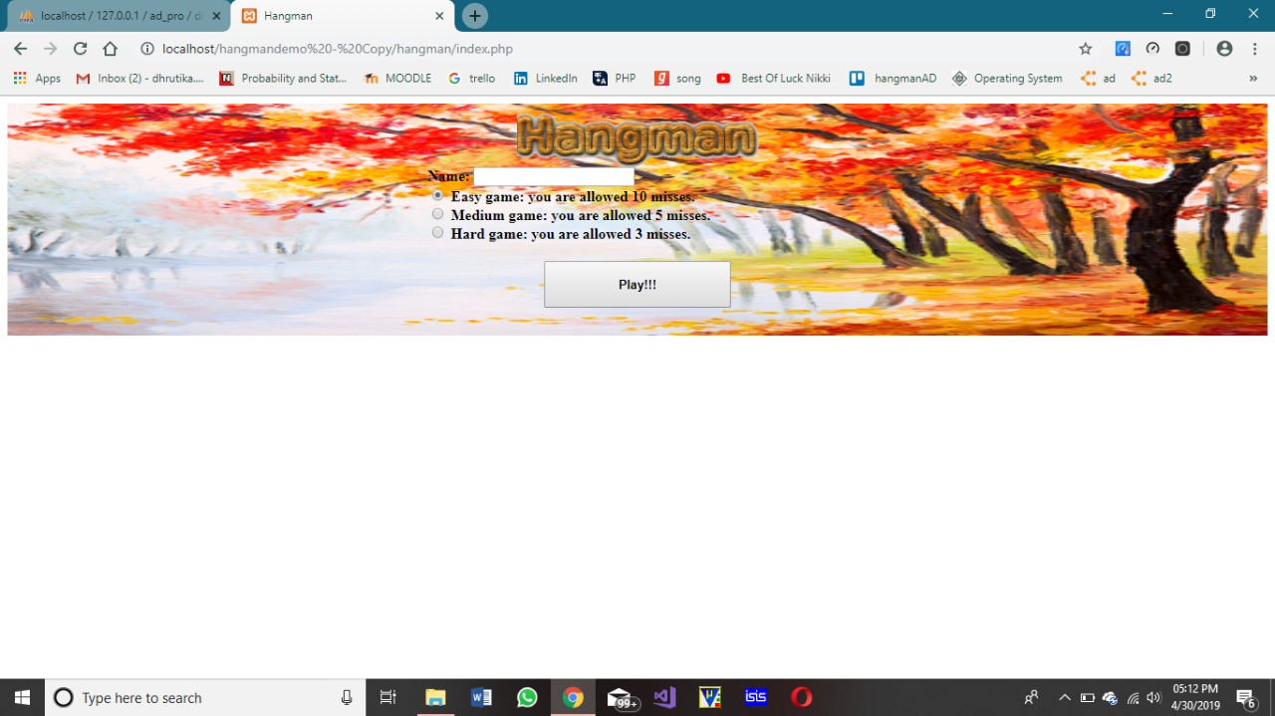

**Playing game**

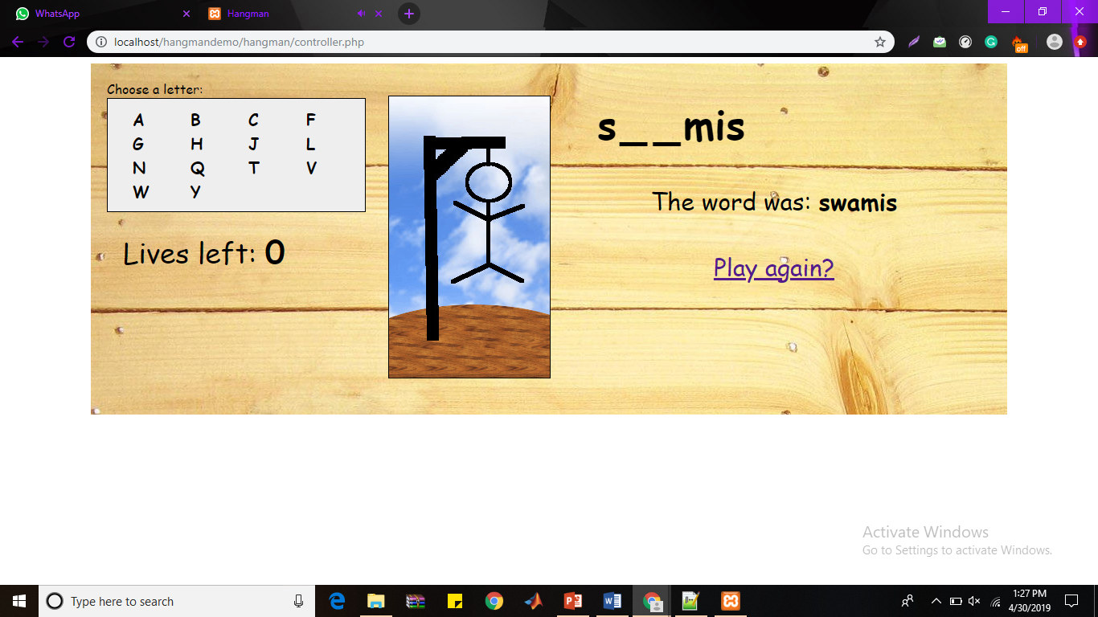

1. **CONCLUSIONS**

This game can have varied applications in the context of word formations and puzzles. Its knowledge can be valuable to many other games like CROSSWORD PUZZLES, WHEEL OF FORTUNE,SCRABBLE. We can also have an investigation of very popular and commonly used letters in most of the words. Make a frequency distribution in graph out of it. The underlying mathematical concepts are Data Collection and Analysis, Presentation and Interpretation which can have lot of implications in language processing and study of graphs and testing conjectures.

1. **REFERENCES**

* Tutorials Point
* w3school
* Geeks for Geeks